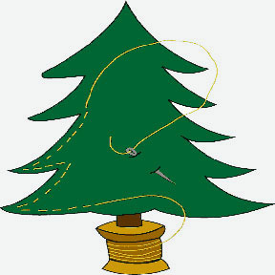 **American Sewing Guild**

**Gold Country Chapter**

**Placerville, CA**

Summer Sewing Day Camp

**Light of the Hills Lutheran Church**

**3100 Rodeo Road, Cameron Park, CA 95682**

**Thurs- Saturday, July 11th– 13th, 2024**

**Thursday & Friday: 9am-5pm, Saturday: 9am-2pm**



**Member: $20, Non-Member: $25**

**Seats are limited to 30. First Come, First Served.**

* Bring your sewing machine & supplies. They will be securely locked overnight.
* Show and Tell. Door prizes.
* Education topics: TBD
* Bring Your Own Lunch. Snacks and drinks will be provided.

* Register on-line: Go to

<https://events.eventzilla.net/e/gold-country-ags--2024-sewing-day-camp-2138611095>

* Register by mail: Write a check, make it **payable to Gold Country ASG**; and send the check, with your phone number, email address, to

**Callie Neville at 6661 Thunder Head Lane, Placerville, CA 95667.**

For more information, please contact

Huong Doan, 916-425-9551, hdoan54@yahoo.com , or

Louise Mast, 909-493-0350 , [lbmast@yahoo.com](mailto:lbmast@yahoo.com),